**DEPENDENT VARIABLE: IN EDUCATION (inedu)**

2010: Sample without NA´s in ID and only risk population 2.574, ages of interviewees from 4 to 60, mean 11, median 8.

2013: Sample without NA´s in ID 17.064, ages of interviewees from 2 to 100, mean 31, median 29, subjects in education at the time of the survey 5.818 and without education 10.042.

2016: Sample without NA´s in ID 14.944, ages of interviewees from 5 to 96, mean 34, median 32, subjects in education at the time of the survey 5.097 and without education 9.296.

Dataset with wave 1, wave 2 and wave 3, dropping NA´s from inedu variable (1.755) and subsetting the sample to ages 6 to 17 years 🡪 data01 sample size 10.313.

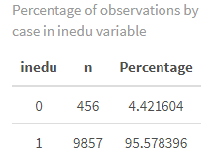

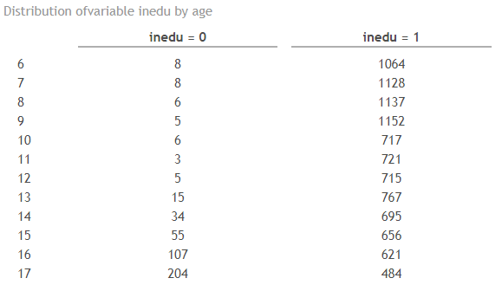

**DEPENDENT VARIABLE: DROP EDUCATION (drop_edu)**

Only takes into account the wave 2 and wave 3 because the question is not asked in wave 1.

2013: Same characteristics in size sample and age mentioned before, subjects that dropped education for at least two months in the last 3 years 148 and subjects that stayed studying 3.184.

2016: Same characteristics in size sample and age mentioned before, subjects that dropped education for at least two months in the last 3 years 207 and subjects that stayed studying 3.190.

Dataset with wave 2 and 3, dropping NA´s from drop_edu (25.279) and subsetting the sample to ages 6 to 17 🡪 data01.1 sample size 6.264.

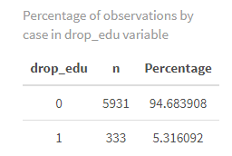

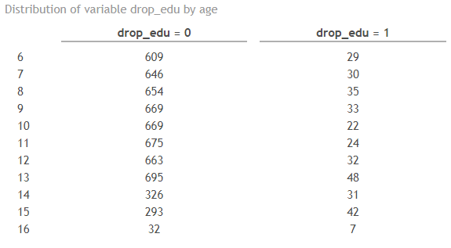

**INDEPENDENT VARIABLES**

**PARENT´S EDUCATION (General)**

For the independent variable “parent´s education” in the dataset I have the education of mothers and the education of fathers independently for each wave. This variable is going to be understood as time fixed, so the values are taking from the wave 1, in 2010. The sample size after eliminating NA´s from mother´s and father´s education plus the category “No info” the analytical sample is of 10.500.

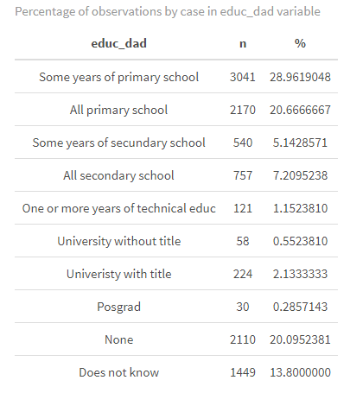

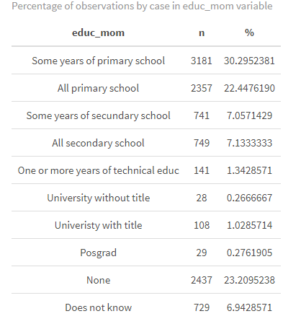

**PARENT´S EDUCATION (with the dependent variable inedu)**

The sample of the variables mother´s education and father´s education matched with the analytical sample of the dependent variable inedu has a size of 511 observations.

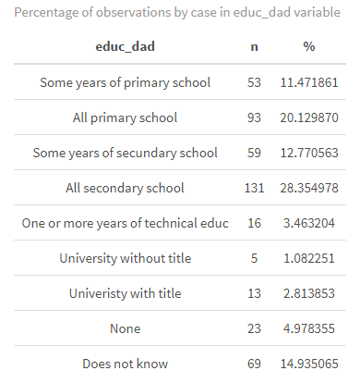

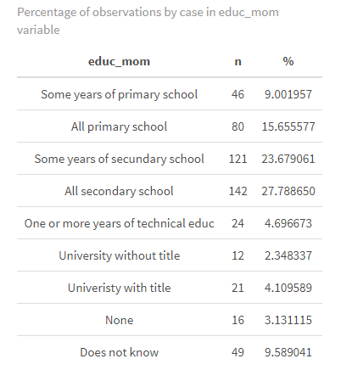

**PARENT´S EDUCATION (with the dependent variable drop_edu)**

The sample of the variables mother´s education and father´s education matched with the analytical sample of the dependent variable drop_edu has a size of 232 observations.

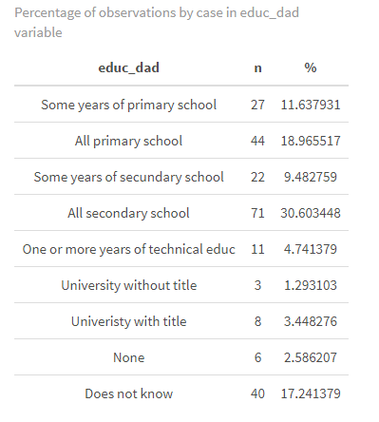

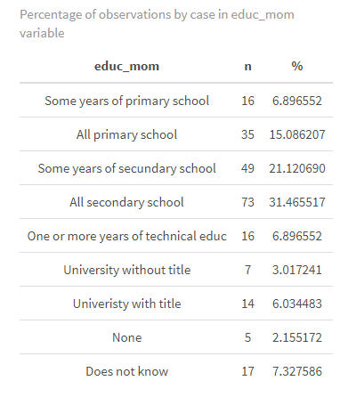

**HOUSEHOLD (income)**